The Blue Goose Int’l- Va Pond’s 13th Annual Shuckin’ & Jivin’ Oct 18, 2023
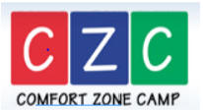

Sponsorship Opportunities Include;
_____- Primary Event/Prize Sponsor $500 preferred verbal & sign recognition
- Big Dawgs $250 verbal & sign recognition
- Toe Tappers $ verbal & sign recognition

Please help us make this an incredible event and help out a very worthy cause!
Name;________________________________
Company;____________________________
EMAIL_______________________________
Address;_____________________________
_____________________________
Make checks payable to; The Blue Goose Int’l
Mail check & sponsorship form to; Rick Bulifant
c/o H.F. Bulifant & Sons Inc. 2001 Semmes Ave Richmond VA 23225

